A PBL-II Synopsis on
Disaster Management and Resource Allocation System

Submitted to Manipal University Jaipur
Towards the partial fulfillment for the Award of the Degree of
BACHELORS OF TECHNOLOGY
In Computers Science and Engineering
2025-2026

By
Aditya Aggarwal
2427030522


Under the guidance of
Dr. Mayank Namdev

______________________________
Signature of Supervisor

Department of Computer Science and Engineering
School of Computer Science and Engineering
Manipal University Jaipur
Jaipur, Rajasthan
INTRODUCTION TO PROBLEM -
APPLICATION BASED
Disasters—whether natural such as floods, earthquakes, cyclones, and wildfires, or man-made such as industrial accidents and chemical spills—pose significant threats to life, property, and the environment. Their impact is often amplified by the lack of timely information, inadequate planning, and inefficient allocation of critical resources like medical supplies, rescue teams, transportation units, and relief materials.
Traditional disaster management methods rely heavily on manual coordination, paper-based communication, and delayed decision-making, which result in slow response times and mismanagement of resources. In large-scale or rapidly evolving disasters, these limitations can lead to avoidable casualties, duplication of efforts, and shortages of essential resources in the areas most in need.
Another major challenge is the absence of a central platform that integrates real-time data, assesses severity levels, and recommends optimal resource allocation. Emergency responders, government agencies, and aid organizations often work in silos, leading to fragmented operations and communication gaps. As a result, critical information does not reach the right teams at the right time.
To address these issues, there is a pressing need for an intelligent and coordinated Disaster Management and Resource Allocation System that can streamline communication, analyse real-time data, predict resource requirements, and ensure that relief efforts are executed efficiently. Such a system would support more accurate decision-making, reduce response time, and enhance the overall resilience of communities affected by disasters.

LITERATURE SURVEY
1) Ushahidi — crowdsourced reporting platform
Pros
- Enables rapid, low-cost collection of eyewitness reports (SMS, web, social), improving situational awareness in early hours.
- Easy to deploy and widely adopted (many countries / events), good for community engagement.
Cons
- Data quality and veracity issues (rumours, duplicate or malicious reports) require heavy moderation or verification.
- Limited built-in geospatial/asset-management capabilities compared with full-fledged DM suites (needs integrations).
2) Sahana Eden — open-source disaster management system (coordination / asset/personnel tracking)
Pros
- Feature-rich for coordination: shelters, hospitals, volunteers, inventories and geospatial layers — built specifically for DM workflows.
- Open-source and extensible; strong track record in humanitarian deployments.
Cons
- More complex to install/customize than lightweight tools; requires technical capacity for full value.
- Usability and mobile UX can lag modern commercial SaaS unless customized.

3) GDACS (Global Disaster Alert & Coordination System) — alert aggregation and coordination
Pros
- Centralized rapid alerts and event severity estimates for earthquakes, cyclones, tsunamis — integrates satellite/sensor feeds for situational awareness.
- Backed by UN/EU partnerships — trusted for international coordination.
Cons
- Global-level alerts are coarse — local decision-makers still need localized, high-resolution data.
- Not a full resource-allocation system (requires downstream integration with logistics/operations platforms).

4) Incident Command System (ICS) / NIMS — organizational method for command & control
Pros
- Provides standard chain-of-command, roles, terminology and scalable structure that improves multi-agency coordination. Widely adopted and trained.
- Proven to reduce communication failures and duplication in complex incidents.
Cons
- Strict hierarchical model can be inflexible for fast-moving, decentralized responses (e.g., community-led actions or dynamic resource reallocation).
- Requires training and cultural adoption; performance depends on people following procedures under stress.

5) Reinforcement Learning (RL) / AI-based resource-allocation (recent research)
Pros
- RL can optimize dynamic allocation decisions in uncertain, time-varying environments (routing ambulances, dispatching supplies) and learn from feedback. Recent papers show promising multi-objective formulations.
- Can automate trade-offs (time vs cost vs risk) when human operators are overloaded.
Cons
- Data-hungry and brittle needs good simulation environments and realistic training data; risks unsafe or opaque recommendations if not constrained.
- Interpretability, validation and trust remain big hurdles for operational deployment in life-critical decisions.

6) Optimization approaches (MILP, deterministic/stochastic models) for relief logistics
Pros
- Mature mathematical tooling (MILP, stochastic programming) produces provably good or optimal plans for distribution, vehicle routing, and inventory allocation. Useful when problem formulation is accurate.
- Transparent objective functions allow clear trade-off analysis (cost vs time vs equity).
Cons
- Scalability and realism: large-scale, stochastic, multi-modal disasters often produce models that are computationally heavy or require simplifying assumptions.
- They rely on accurate inputs (road network state, demand estimates). In early disaster phases these inputs are uncertain or missing.

7) Drones / UAVs (assessment, SAR, delivery) — both hardware and operational methods (e.g., Zipline)
Pros
- Fast aerial assessment, mapping, and targeted delivery of small, urgent items (medicines, test samples) to hard-to-reach locations — proven in several deployments (medical deliveries, damage mapping).
- Can reduce time-to-service and provide real-time imagery to decision-makers.
Cons
- Regulatory, endurance, payload and airspace coordination constraints; weather severely limits utility.
- For large-volume logistics, drones are complementary rather than a replacement; they require launch/recovery infrastructure and trained operators.

8) IoT / Wireless Sensor Networks (WSN) for Early Warning Systems (EWS)
Pros
- Dense, cheap sensors (water level, seismic, rainfall) + edge connectivity enable localized early detection and faster alerts; many recent reviews show growth in IoT-based EWS research.
- When combined with local communication channels, can close the “last mile” for warnings.
Cons
- Coverage, power, maintenance, interoperability, and data-veracity issues — sensors can fail or give false alarms; scaling to whole regions is costly.
- Often technology-centric designs fail if institutional coordination and community preparedness are weak. Recent field reviews recommend socio-technical integration.

9) Satellite remote sensing & platforms (Sentinel/Copernicus, Planet, Google Earth Engine)
Pros
- Wide-area, repeatable imagery for damage assessment, flood extent mapping and change detection — invaluable when ground access is limited.
- Increasingly accessible via cloud platforms (Earth Engine) for near-real-time analytics and automated damage detection.
Cons
- Temporal and spatial resolution limits: small-scale or rapid events may be missed between passes; cloud cover can block optical sensors.
- Processing and interpretation require expertise; deriving actionable logistics decisions from raw imagery needs integration with ground data.

10) Blockchain for aid/supply-chain tracking and transparency
Pros
- Immutable ledgers promise transparent tracking of donations, provenance of supplies and tamper-evident logs — can reduce fraud and improve donor trust. (Emerging pilots exist.)
Cons
- Blockchain often adds complexity, latency and doesn't solve the fundamental problem of “garbage in” (incorrect on-chain data). Integration costs and privacy concerns limit adoption. (Less mature in large-scale DM.)
(Note: blockchain is still experimental in disaster logistics — practical evidence is limited compared with other systems.)

COMPARATIVE STUDY
S. No. | Method / System / Technology | Type | Pros | Cons
1 | Ushahidi (Crowdsourced Reporting Platform) | Software | - Fast, low-cost crowd-based data collection.- Easy deployment in emergencies.- Improves early situational awareness. | - Reports may be inaccurate or unverified.- Needs human moderation.- Limited in advanced resource allocation features.
2 | Sahana Eden (Disaster Management System) | Software | - Comprehensive modules: shelters, volunteers, logistics.- Open-source and customizable.- Used by global relief agencies. | - Requires trained technical staff for deployment.- Interface feels dated without customization.- Setup and maintenance overhead.
3 | GDACS (Global Disaster Alert & Coordination System) | Software + Data Platform | - Real-time global alerts (earthquakes, cyclones, tsunamis).- Integrates satellite and sensor data.- Trusted by UN and EU bodies. | - Provides macro-level data; lacks local detail.- Not a complete logistics solution.- Needs integration for resource allocation.
4 | ICS / NIMS (Incident Command System) | Organizational Method | - Standardized command hierarchy.- Enhances inter-agency coordination.- Minimizes communication confusion. | - Rigid in highly dynamic or decentralized events.- Requires extensive training.- Effectiveness depends on proper human adherence.
5 | Reinforcement Learning for Resource Allocation | AI Research / Algorithm | - Learns optimal strategies under uncertainty.- Supports dynamic, real-time decision-making.- Handles multi-objective optimization. | - Needs large training datasets.- Limited interpretability of decisions.- Requires safety constraints and human oversight.
6 | Optimization Models (MILP, LP, Stochastic Programming) | Algorithm / Research | - Generates optimal and transparent plans.- Widely applied in logistics and routing.- Good for planning before and during early disaster stages. | - Computationally expensive at large scale.- Relies on accurate input data.- May oversimplify real-world complexity.
7 | Drones / UAVs for Assessment & Delivery | Hardware | - Rapid aerial mapping and damage assessment.- Access hard-to-reach areas.- Can deliver medicines and essentials quickly. | - Limited payload and battery life.- Weather-dependent and regulated.- Requires trained operators and equipment.
8 | IoT / Wireless Sensor Networks (EWS) | Hardware + Software | - Real-time environmental monitoring (floods, quakes).- Enables faster early warnings.- Low-cost sensors scalable across regions. | - Sensors prone to failure or false alerts.- Power and connectivity issues.- Requires maintenance and redundancy.
9 | Satellite Remote Sensing (Sentinel, Planet, GEE) | Hardware + Analytics | - Wide-area coverage for floods, fires, and damage mapping.- Useful when ground access is impossible.- High availability via cloud platforms. | - Cloud cover affects optical sensors.- Requires expert interpretation.- Temporal resolution may be low for fast events.
10 | Blockchain for Relief Supply Chain Tracking | Software / Emerging Tech | - Ensures transparency and tamper-proof records.- Can reduce fraud or loss of donated materials.- Improves accountability across agencies. | - Adds complexity with little added value in early stages.- High implementation cost.- Still experimental in real disaster operations.

PROBLEM STATEMENT

Disaster response efforts often suffer from delayed information flow, uncoordinated decision-making, and inefficient allocation of critical resources such as rescue teams, medical supplies, shelters, and transportation. Existing systems operate in silos, depend heavily on manual processes, and lack real-time data integration from diverse sources like sensors, satellites, emergency reports, and field personnel. As a result, authorities face challenges in accurately assessing disaster impact, predicting resource requirements, and deploying aid to the right locations at the right time. These limitations lead to increased response time, resource shortages in high-need areas, duplication of efforts, and avoidable loss of life and property. Therefore, there is a pressing need for an intelligent, integrated Disaster Management and Resource Allocation System that can provide real-time situational awareness, streamline coordination among agencies, and ensure optimal utilization of available resources during emergency situations.

OBJECTIVE
1. To develop a centralized system that provides real-time situational awareness by integrating data from multiple sources such as sensors, satellite imagery, field reports, and communication devices, enabling faster and more accurate assessment of disaster conditions.
2. To design an intelligent resource allocation module that optimizes the distribution of critical resources—including rescue personnel, medical supplies, transportation units, and relief materials—based on severity, priority, and real-time demand to minimize response time and reduce loss of life and property.
3. To enhance coordination and communication among government agencies, emergency responders, and humanitarian organizations through a unified platform that supports timely decision-making, transparent information sharing, and efficient management of relief operations.
4. To implement a user-friendly interface and alert mechanism that allows authorities, responders, and affected communities to easily report incidents, receive timely warnings, and access critical information during disaster events.
5. To enable data-driven decision-making and post-disaster analysis by maintaining detailed records of resource usage, response timelines, and operational outcomes, allowing continuous improvement of disaster preparedness and response strategies.

PROPOSED SOLUTION
The development of the Disaster Response and Resource Optimization System (DRROS) follows a systematic methodology that combines requirement analysis, data integration, intelligent modelling, system design, and validation to ensure an effective and robust solution. The methodology consists of the following steps:

1. Requirement Analysis and Problem Understanding
A detailed analysis of existing disaster management challenges is conducted through literature review, stakeholder interviews, and examination of current systems. Functional and non-functional requirements are identified, including real-time data processing, scalability, multi-agency coordination, and intelligent resource allocation.

2. Data Collection and Source Integration Planning
Different data sources such as IoT sensor feeds, satellite imagery, meteorological alerts, historical disaster records, crowdsourced reports, and government databases are identified. A data acquisition framework is designed to ensure smooth ingestion, cleaning, and preprocessing of heterogeneous data streams for real-time use. The system now incorporates real-time data streams through API integration, specifically leveraging GDACS for global disaster alerts and OpenWeatherMap for environmental data. This ensures continuous data flow into the system, enabling dynamic updates and real-time decision-making instead of relying solely on static or simulated datasets.

3. System Architecture Design
A modular, multi-layered architecture is crafted consisting of:
- Data Layer: Collects and preprocesses real-time and historical data.
- Processing Layer: Handles analytics, event detection, and situation assessment.
- AI/Optimization Layer: Implements machine learning and optimization algorithms for resource allocation.
- Application Layer: Provides interfaces for authorities, responders, and users.
- Communication Layer: Enables alert dissemination and inter-agency collaboration.
This architecture ensures flexibility, scalability, and fault tolerance.

4. Development of Event Detection and Prediction Models
Machine learning and analytical techniques are applied to detect anomalies, identify disaster onset, classify severity levels, and forecast resource needs. Models such as time-series forecasting, clustering, or supervised learning may be employed depending on data availability and disaster types.

5. Design and Implementation of Resource Optimization Algorithms
Optimization models (e.g., MILP, heuristic algorithms, or reinforcement learning) are developed to determine optimal distribution of resources like rescue teams, medical units, shelters, food supplies, and transport vehicles. The algorithms consider parameters such as urgency, distance, resource availability, road conditions, and victim density.

6. User Interface and Communication Module Development
Interactive dashboards, mobile interfaces, and communication tools are designed for emergency responders, administrators, and citizens. The UI provides real-time maps, alerts, resource status, and decision-support suggestions. Push notifications, SMS alerts, and broadcast systems are integrated to ensure rapid delivery of warnings.

7. System Integration and Interoperability Testing
All modules—including data ingestion, prediction models, optimization algorithms, and user interfaces—are integrated into a unified platform. Interoperability is tested to ensure seamless communication with external systems such as government alert networks, sensor platforms, and GIS tools.

8. Performance Evaluation and Validation
The system is tested using simulated disaster scenarios, historical datasets, and test cases based on real-world disaster events. Performance metrics such as response time, prediction accuracy, resource allocation efficiency, and system reliability are evaluated. Feedback from domain experts and stakeholders is collected for refinement.

9. Deployment and Training
The final system is deployed in a cloud or hybrid environment for scalability. Training sessions are conducted for disaster-management authorities, emergency responders, and administrative staff to ensure smooth adoption.

10. Continuous Monitoring, Updating, and Maintenance
Post-deployment, the system is continuously monitored for performance issues. Models are retrained with new data, optimization rules are updated, and software patches are applied. User feedback guides future improvements and ensures long-term system relevance.

11. Real-Time API Integration and Dynamic Data Processing
The system integrates external APIs such as GDACS and weather services to fetch live disaster and environmental data. This data is continuously processed and fed into the allocation engine, enabling real-time prioritization and adaptive resource deployment based on evolving conditions.

SCREENSHOTS

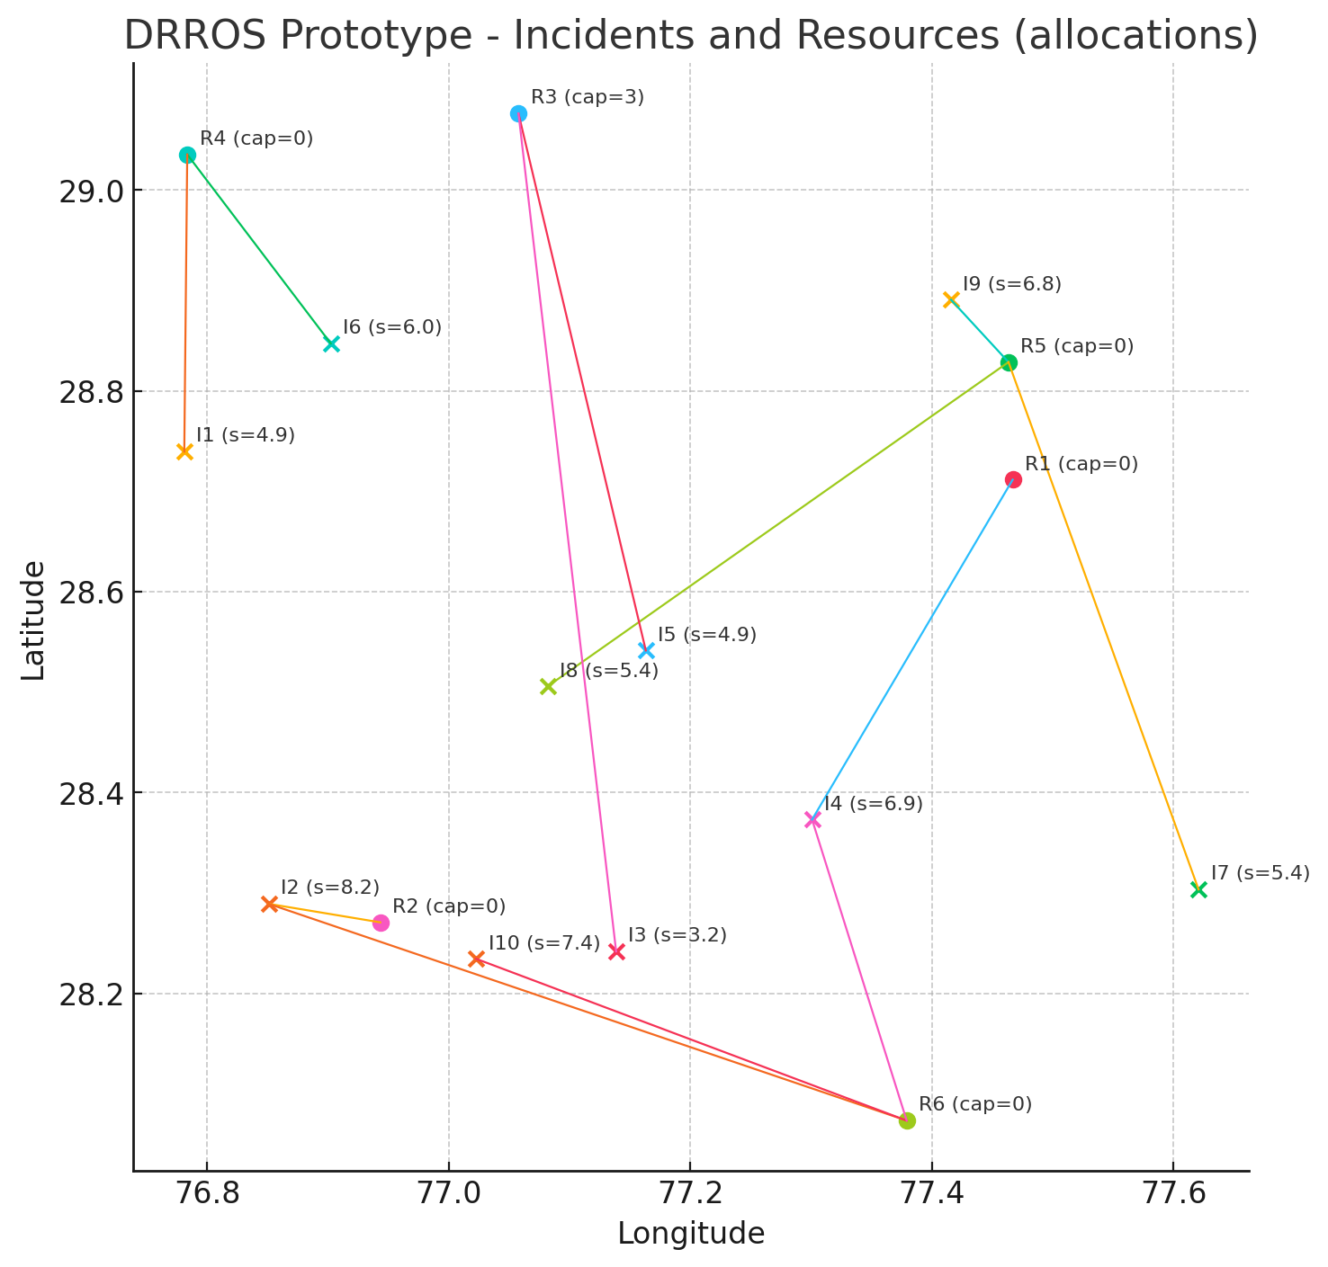

API Integration and Real-Time Data Processing
The primary API integrated into the system is the Global Disaster Alert and Coordination System (GDACS), which provides real-time information about global disaster events such as earthquakes, cyclones, and floods. The GDACS GeoJSON API is used to extract structured data including event location (latitude and longitude), disaster type, and alert severity levels (Green, Orange, Red).
In addition to disaster data, the system integrates a weather API (OpenWeatherMap) to retrieve real-time environmental conditions for each incident location. Weather conditions such as rain, storms, or clear skies are used to adjust the urgency of disaster response dynamically.
The integration process involves:
- Fetching real-time disaster events from GDACS
- Parsing and converting API data into structured Incident objects
- Mapping GDACS alert levels to numerical severity values
- Fetching weather conditions for each incident location
- Incorporating weather-based weighting into the resource allocation algorithm
This API-driven approach transforms DRROS into a real-time, data-driven system capable of adapting to changing disaster conditions and improving response efficiency.

CONCLUSION
The implementation of API integration is achieved using HTTP requests to external endpoints, followed by parsing of JSON/GeoJSON responses. Disaster events are extracted from GDACS and converted into structured objects used by the allocation engine. Weather data is fetched dynamically for each incident location and incorporated into the scoring function as a weighting factor. The allocation algorithm is enhanced to include this environmental factor, resulting in a more context-aware and realistic optimization process.

OUTPUT
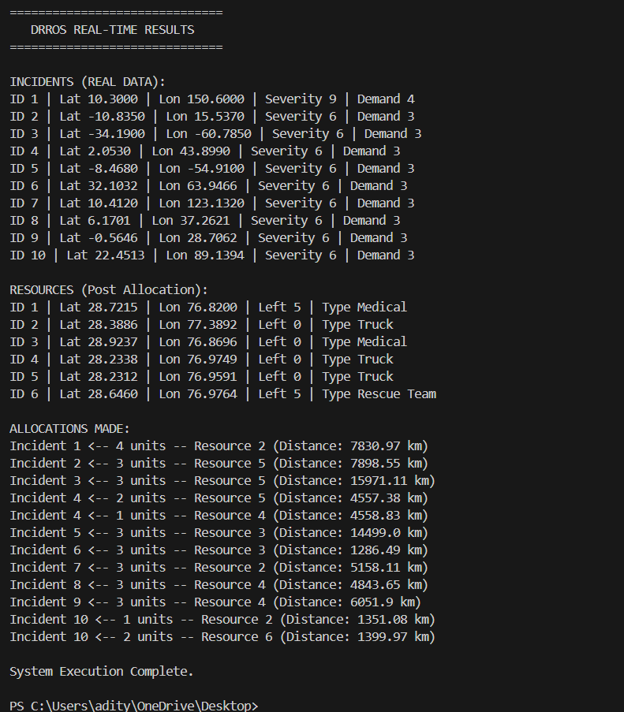
BIBLIOGRAPHY
  - Okolloh, O. (2009). Ushahidi, or ‘testimony’: Web 2.0 tools for crowdsourcing crisis information. Participatory Learning and Action, 59(1), 65–70.
  - Currion, P., Silva, C. D., & Van de Walle, B. (2007). Open source software for disaster management. Communications of the ACM, 50(3), 61–65.
  - De Groeve, T., et al. (2015). Global Disaster Alert and Coordination System (GDACS): Overview, Improvements and Impact. JRC Science and Policy Report, European Commission.
  - U.S. Federal Emergency Management Agency (FEMA). (2017). National Incident Management System (NIMS) Guide.
  - Yu, X., et al. (2020). Reinforcement learning for resource allocation in emergency management: A review. Safety Science, 132, 104967.
  - Caunhye, A. M., Nie, X., & Pokharel, S. (2012). Optimization models in emergency logistics: A literature review. Socio-Economic Planning Sciences, 46(1), 4–13.
  - Erdelj, M., Krol, M., & Natalizio, E. (2017). UAV-assisted disaster management: Applications and open issues. Ad Hoc Networks, 28, 2–25.
  - Alahi, M. E. E., et al. (2018). IoT-based flood monitoring systems: A review. Sensors, 18(11), 3948.
  - Joyce, K. E., et al. (2009). A review of the status of satellite remote sensing and image processing techniques for mapping natural disasters. Progress in Physical Geography, 33(2), 183–207.
  - Gupta, M. (2017). Blockchain for humanitarian aid and disaster relief: A systematic review. Journal of Humanitarian Logistics and Supply Chain Management, 7(3), 285–308.

